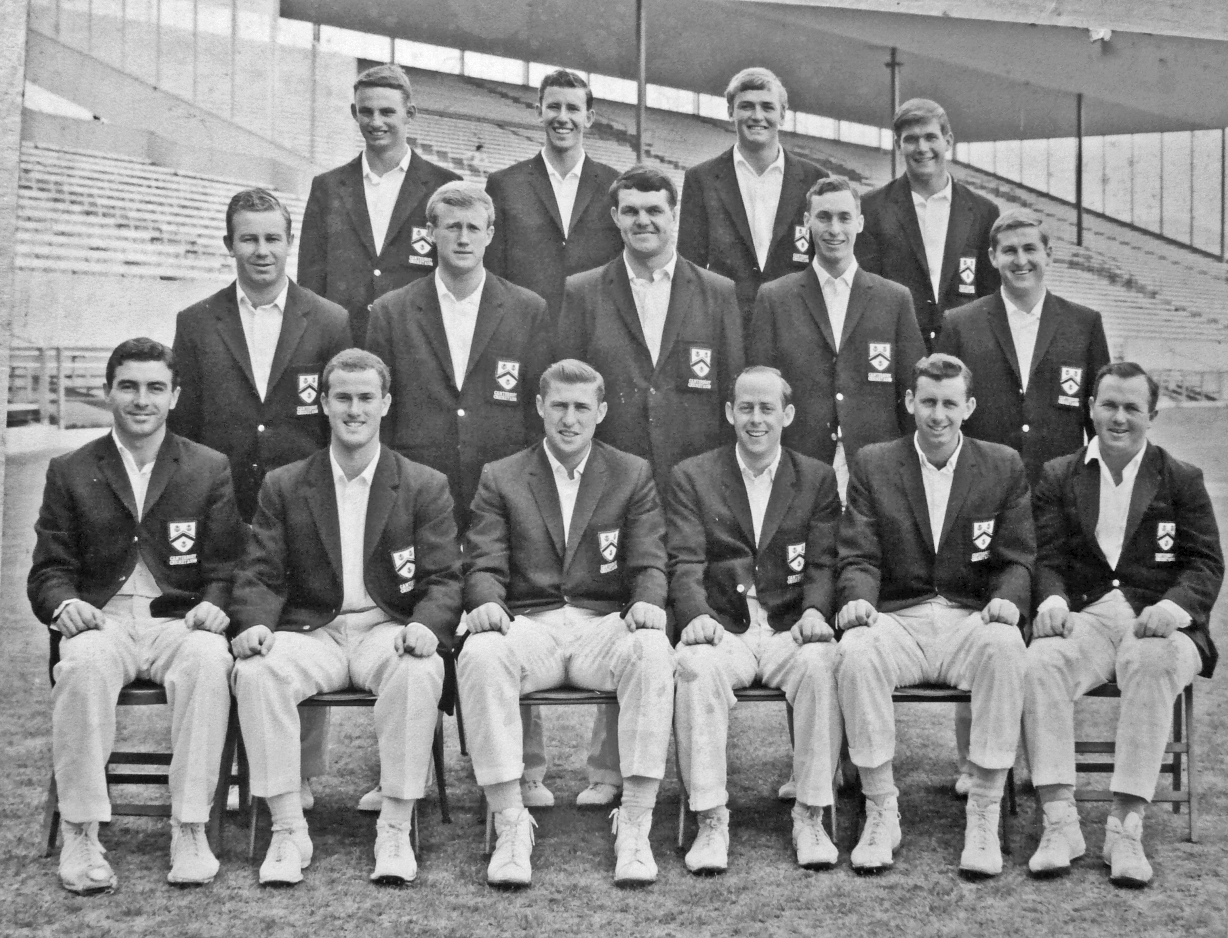

**Canterbury Representative team 1965/66**

**Back row:** CL Bull, WJ Burtt,GW Henry, RM Gearry

**Middle row:** DL Gallop, PA Sharp, IR Hartland, BG Hadlee, ML Ryan

**Front row:** GA Bartlett, JM McIntyre, RC Motz, BF Hastings (captain), BR Taylor, K Thomson

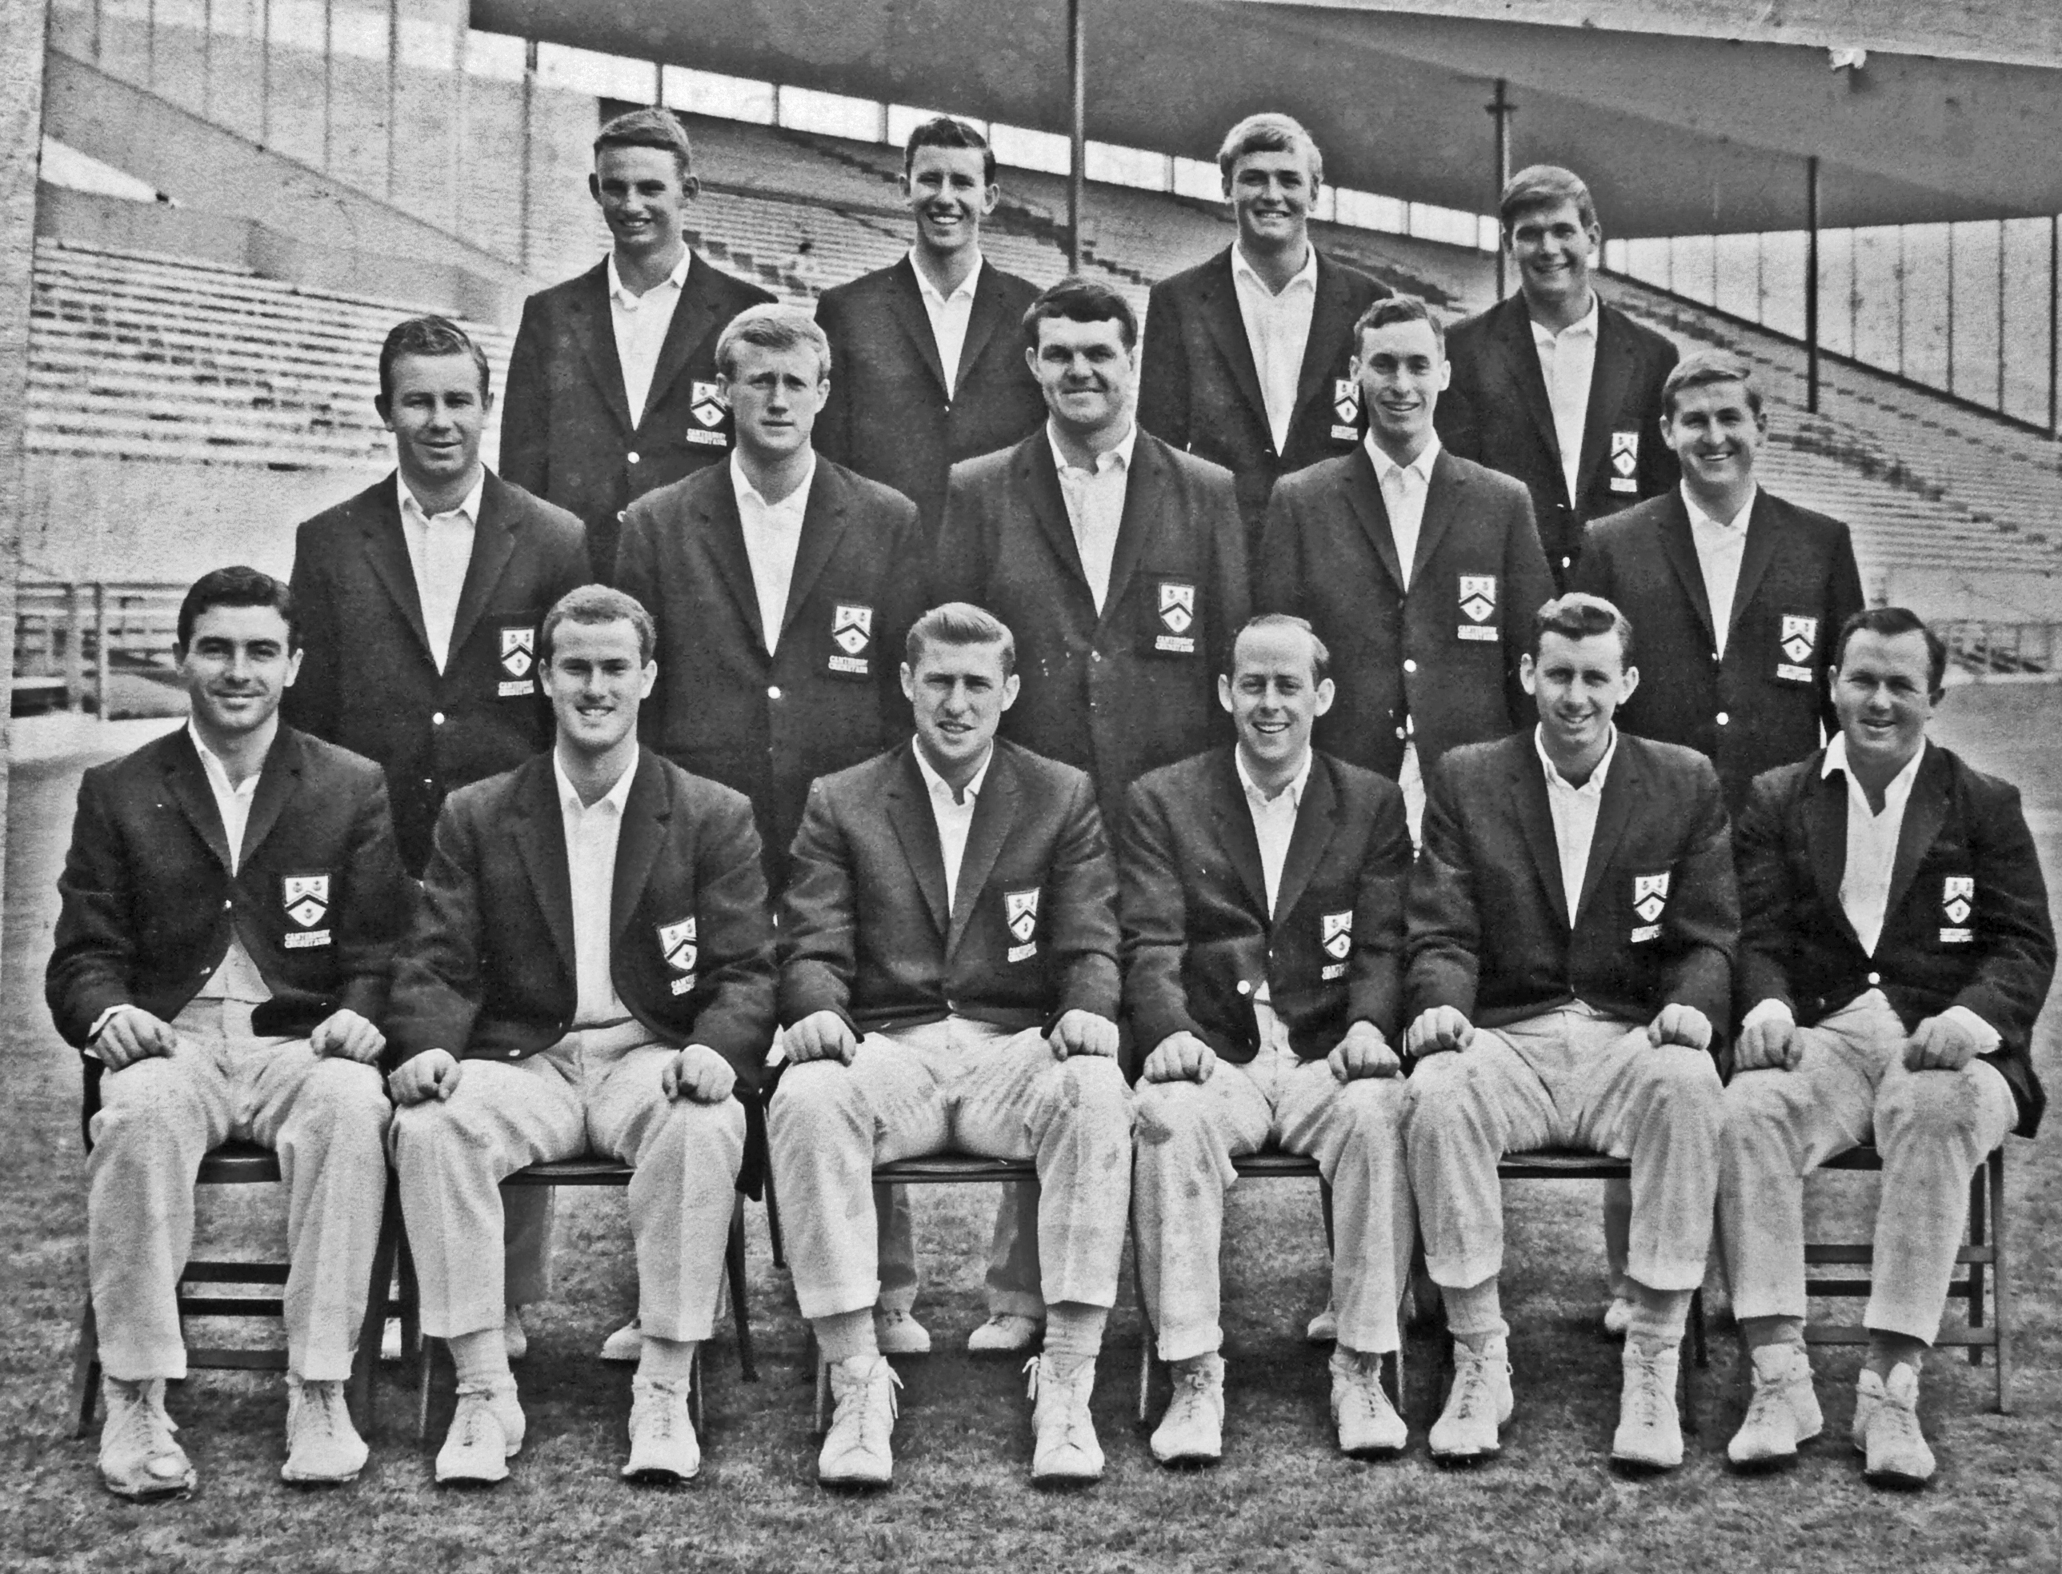

Canterbury Representative Team 1965/66

Back Row: CL Bull, JW Burtt, G Hnry, RM Gearry

Middle Row: DL Gallop, PA Sharp, IR Hartland, BG Hadlee, ML Ryan

Front Row: GA Bartlett, JM McIntyre, RC Motz, BF hastings, BR Taylor. K Thomson